Instructions King (1 – 2 – HD – BoS)

Risky stars

Our second game is called “Risky stars”. The computer will decide with whom you play that game. One of you will be “BLUE” and the other will be “YELLOW”. The computer also decides who is “BLUE” and who is “YELLOW”.

If you are BLUE, your screen looks like this.



At the top of the screen, it says you are BLUE. In the middle of the screen there is a carpet divided in two. You own the BLUE star. You need to decide whether to put your star on the carpet or outside the carpet.

If you are YELLOW, your screen looks like this.

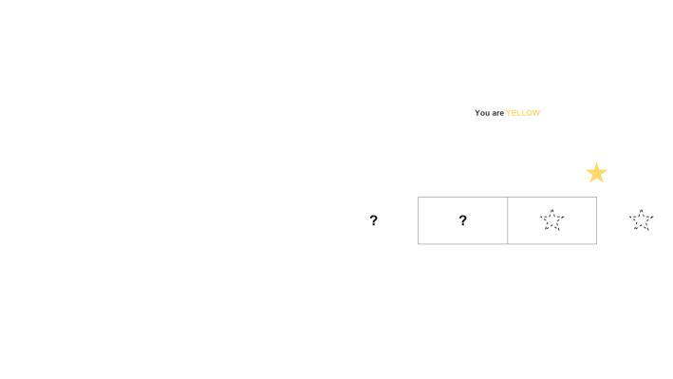

It says you are YELLOW at the top and you see the same carpet as your partner. You own the YELLOW star and you need to decide whether to put your star on the carpet or outside the carpet.

Here you can see the screen of BLUE and the screen of YELLOW.

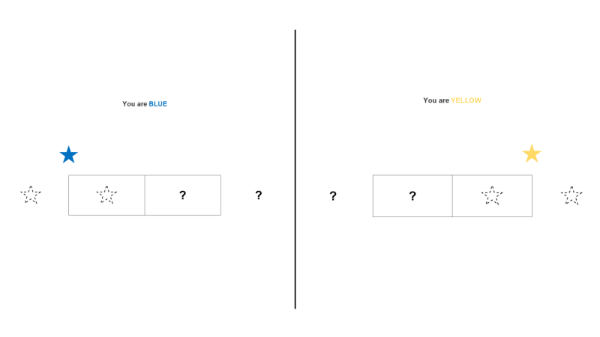

Now, how do you get points?

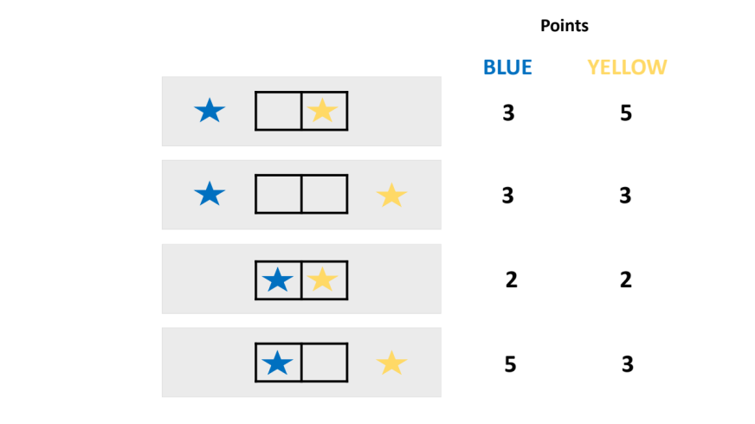

If you put your own star outside the carpet, you get 3 points, no matter what your partner does. If you put it on the carpet, what you get depends on what your partner does. If he also puts his star on the carpet, neither of you fits well and you both earn 2 points. But if he puts it outside the carpet, then you have all the space for yourself and you earn 5 points (while he earns 3 points for being outside the carpet). This information will remain here [point] during your choices.

As in our first game, you will play many times with the same partner. Each time, you will make your choices at the same time. This means that you will not know what your partner did when you make your choice. It is only after both of you have made a choice, that you will both know what each of you did and how many points you got. This will appear in the right column of your screen.

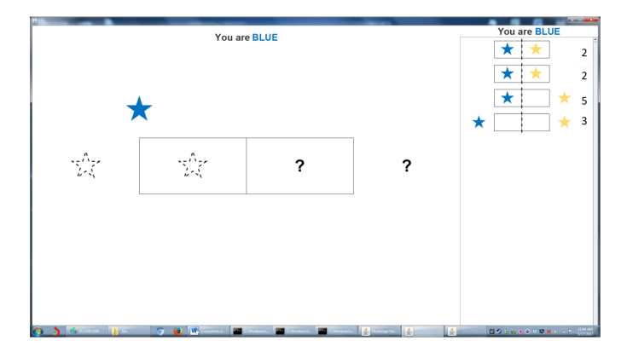

For instance, this is what your screen may look like after 4 rounds.
In the first round:
In the second round
In the third round
You have accumulated a total of 12 points so far.

OK. The computer will now select partners. The points you get depending on where the stars are placed will remain visible on the big screen.

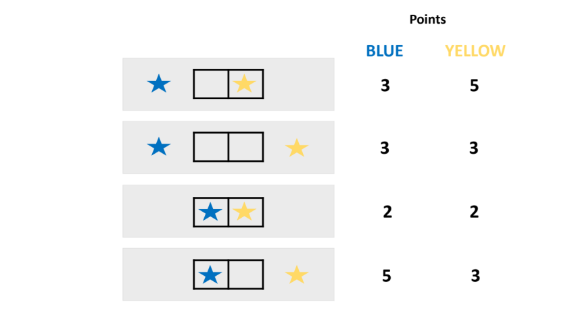

When you are ready, make your choices. Just tap on the screen where you want to place your star.

[At the end of the 1st game]

The game has ended. You can see on your screen the points you have accumulated.

The computer will now select new partners and you will play the same game again. You may have the same role as before but note that it does not matter since the points are the same for both colors.

[At the end of the 2nd game]

The game has ended. You can see on your screen the points you have accumulated.

Find the balance

Our last game is called “Find the balance”. As before, the computer will decide with whom you play this game. One of you will be “RED” and the other will be “GREEN”. The computer decides who is “RED” and who is “GREEN”.

If you are RED, your screen looks like this.

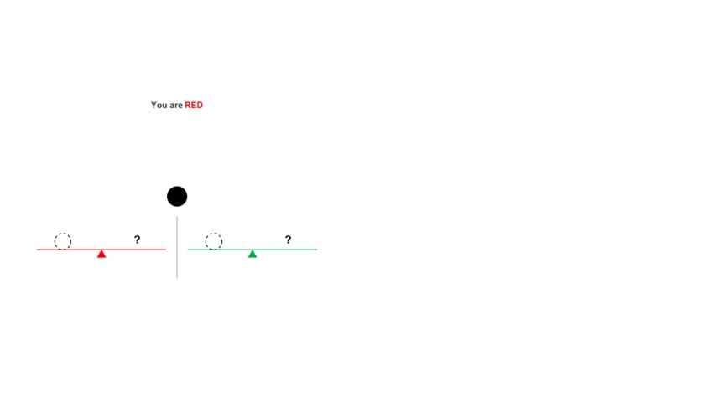

At the top of the screen, it says you are RED. You own the RED scale and the black ball in the middle of your screen. You can also see a GREEN scale, which belongs to your partner. You need to decide whether to put your ball on the dotted circle of your RED scale or on the dotted circle of your partner’s GREEN scale.

If you are GREEN, your screen looks like this.

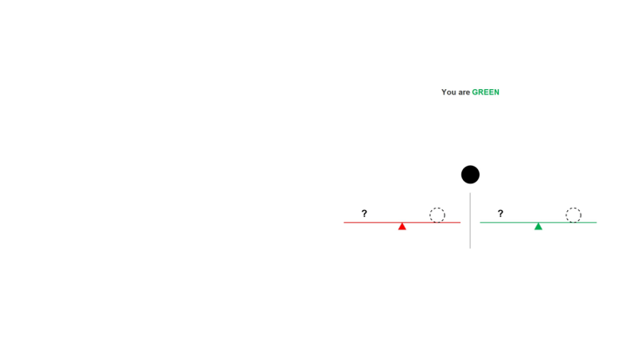

It says you are GREEN at the top. You own the GREEN scale and the black ball in the middle of your screen. You can also see a RED scale which belongs to your partner. You need to decide whether to put your ball on the dotted circle of your GREEN scale or on the dotted circle of your partner’s RED scale.

Here you can see the screen of RED and the screen of GREEN.

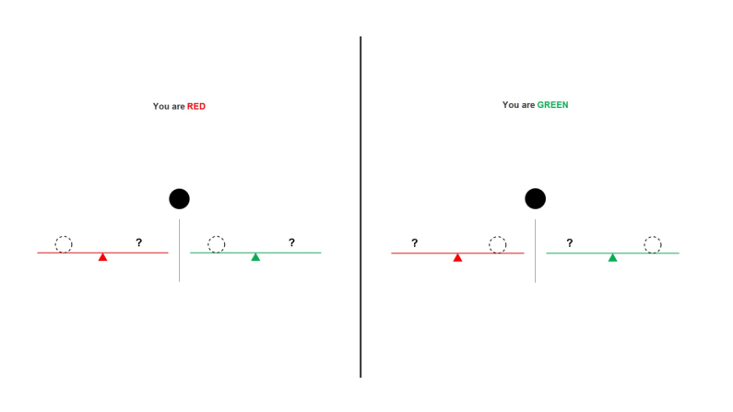
Now, how do you get points?

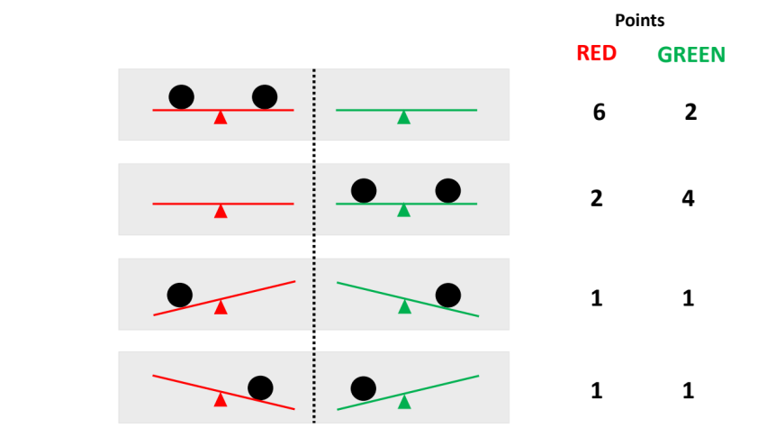

If both balls are put on the RED scale, then player RED gets 6 points and player GREEN gets 2 points. If both balls are put on the GREEN scale, then player RED gets 2 points and player GREEN gets 4 points. If the balls are put on different scales, each player gets only 1 point. This information will remain here [point] during your choices.

Notice that RED gets more points when both balls are on the RED scale than the points GREEN gets when both balls are on the GREEN scale.

Now this is very important. You will play many rounds with the same partner. In each round, you will make your choices at the same time. This means that you will not know what your partner did when you make your choice. However, after both of you have made a choice, you will both know what each of you did and how many points you got. This will appear in the right column of your screen.

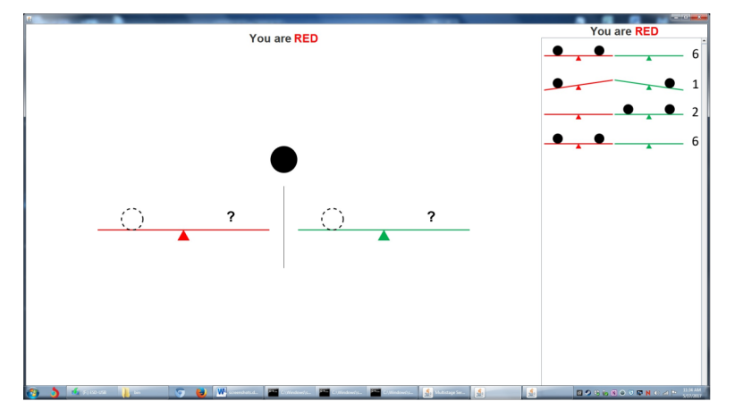

For example, this is what your screen may look like after 4 rounds.
In the first round:
In the second round:
In the third round:
You have accumulated a total of 15 points so far, but you are going to play many more rounds.

All right, are you ready to play? The computer will now select partners.

The points you get depending on where the balls are placed will remain visible on the big screen.

When you are ready, make your choices. Just tap on the screen where you want to place your ball.

[At the end of the 1st game]

The game has ended. You can see on your screen the points you have accumulated.

The computer will now select new partners and you will play the same game again. If you were RED before, you will be GREEN and if you were GREEN you will be RED. Remember the game is the same, but your color role is different and your partner is different.

[At the end of the 2nd game]

The game has ended. Please answer a few questions and we are done.

Payments:

We will now call you one by one and tell you how much money you earned. You can tell your friends how much you got or not. It is totally up to you. You will get today an email from Amazon with an amazon egift card for that amount. If you don’t receive it, please let us know.

Thanks for playing with us.

